TOPIC 5.9 : GREEDY KNAPSACK FOR MAXIMUM WEIGHT LOADING
Problem Statement
Given a list of item weights and the maximum capacity of a container, determine the maximum weight that can be loaded into the container using a greedy approach.
The greedy approach should prioritize loading heavier items first until the container reaches its capacity.
Test Case 1
Input:
n = 5
weights = [10, 20, 30, 40, 50]
max_capacity = 60
Output: 50
Test Case 2
Input:
n = 6
weights = [5, 10, 15, 20, 25, 30]
max_capacity = 50
Output: 50
Aim
To write a program that selects items to load into a container such that the total weight is maximized without exceeding the maximum capacity, using a greedy approach that picks heavier items first.
Algorithm
- Start
- Sort the list of weights in descending order
- Initialize total = 0
- For each weight in the sorted list:
  - If total + weight ≤ max_capacity, add weight to total
  - Otherwise, skip
- Return total
- Stop
Input and Output
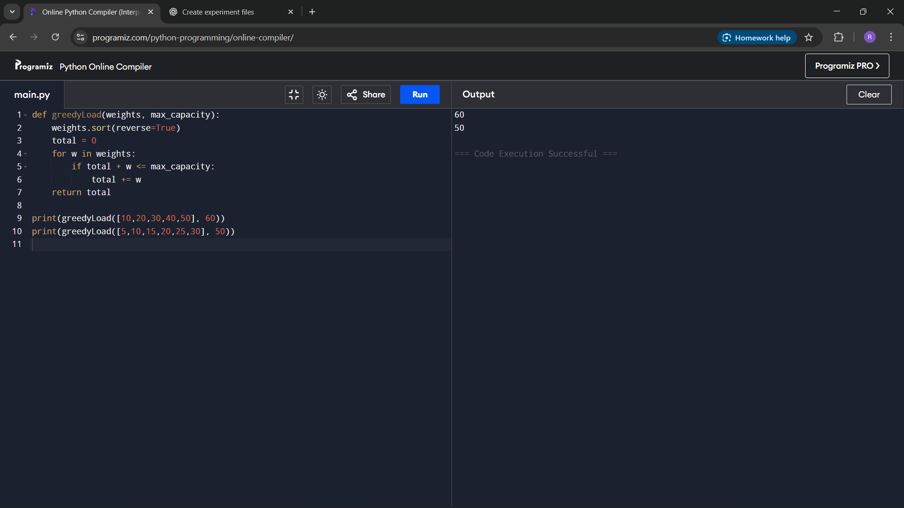
Result
The program successfully computes the maximum weight that can be loaded into the container using the greedy method.
Performance Analysis
Time Complexity: O(n log n) due to sorting
Space Complexity: O(1) for variables

